***Open Source Graphics and Animation Tools***

***Assignment***

***Submitted to***

***Dr. Durgansh Sharma***

***Cybernetics SCS, UPES***

***Submitted By***

*Name: Priyanshu Gautam*

*Roll No: R100218040*

*Sap id : 500069562*

*B. Tech CSE (OSOS)  
Department of Cybernetics*

*COMPUTER SCIENCE & ENGINEERING*

**

***School of Computer Science***

***University of Petroleum and Energy Studies,***

***Dehradun – 248007: Uttarakhand***

Contents

Phase 1 2

Donut Poster using GIMP 2

# Phase 1

## Donut Poster using GIMP

Steps for creating a Doughnut Poster using GIMP

1: Select a picture to draw.

2: Open GIMP.

3: Create a new layer with transparent background.

4: Draw the outline of doughnut with the help brush or pencil tool.

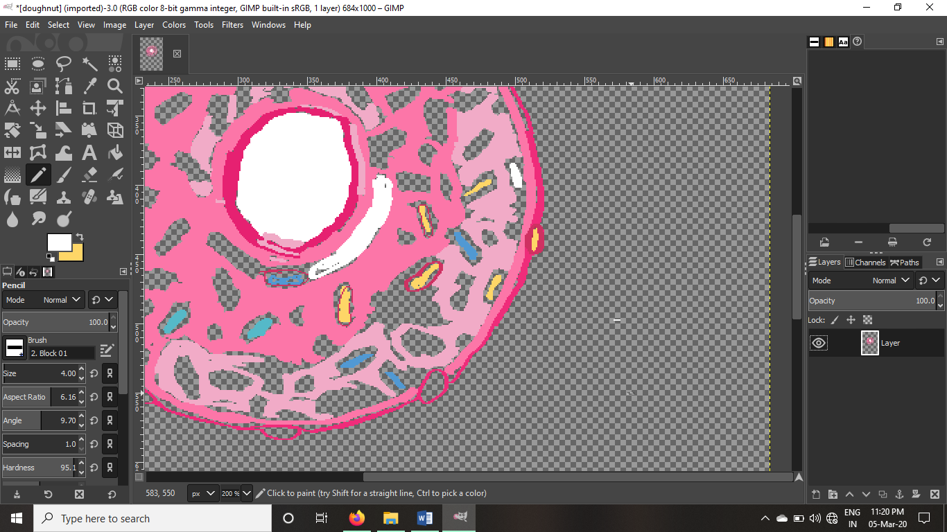

5: Then Select Background layer and with the help of brush/pencil tool fill the background colour.

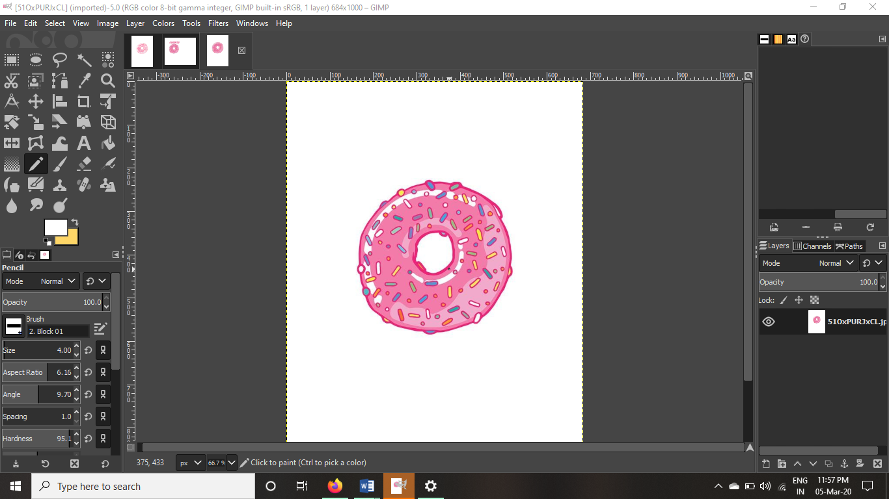

6: Use capital “A” icon to insert text.

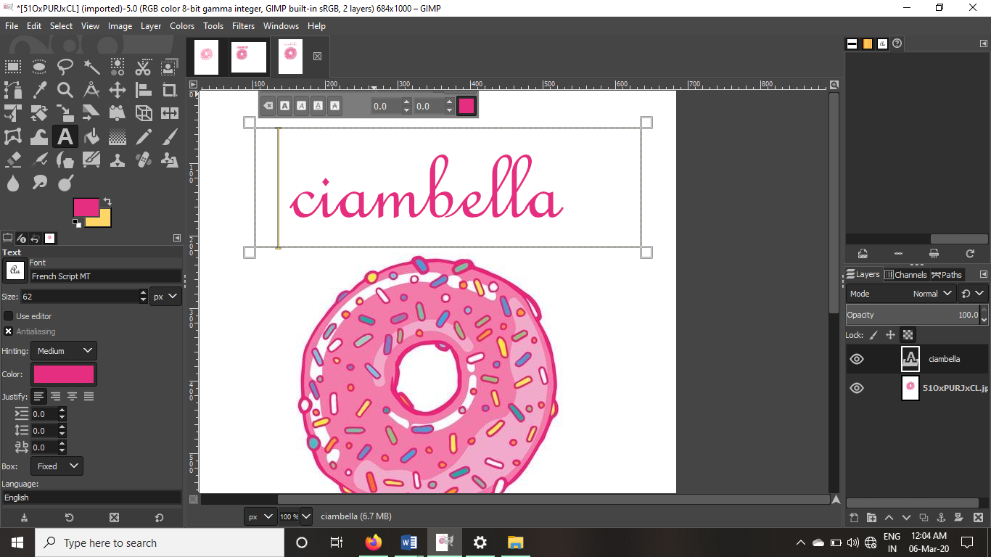

7: To save as JPEG format: go to file option in menu bar. Then select Export option then save it as a JPEG format. Then save it.

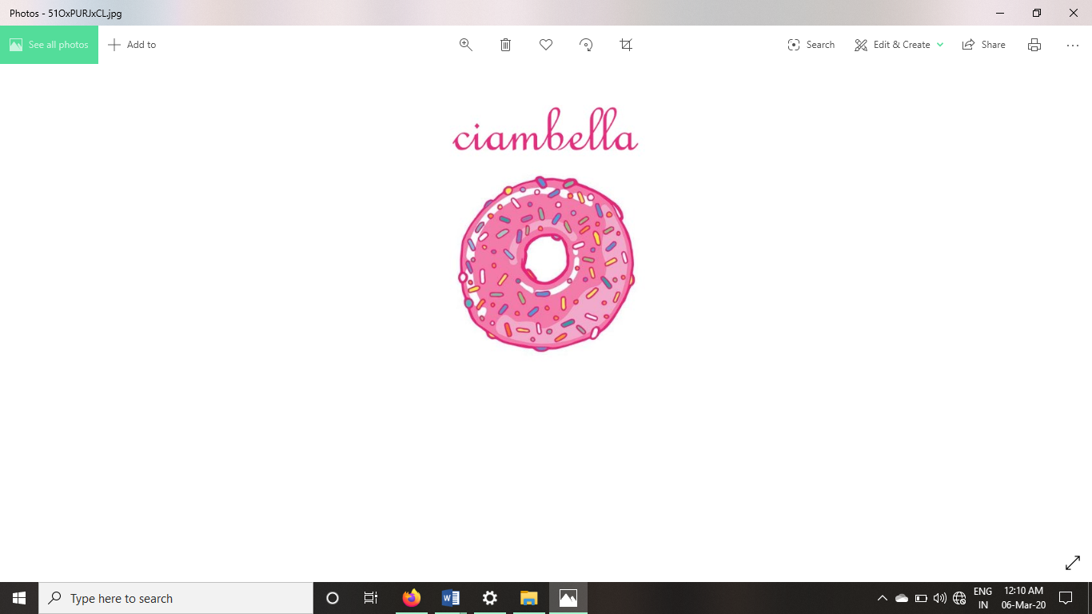

# Phase 2

## Draw ice cream using blender 2.8

Steps for drawing an ice cream using Blender 2.8

1: Select a picture to draw.

2: Open blender.

3: First delete the default figures using x and then selecting delete.

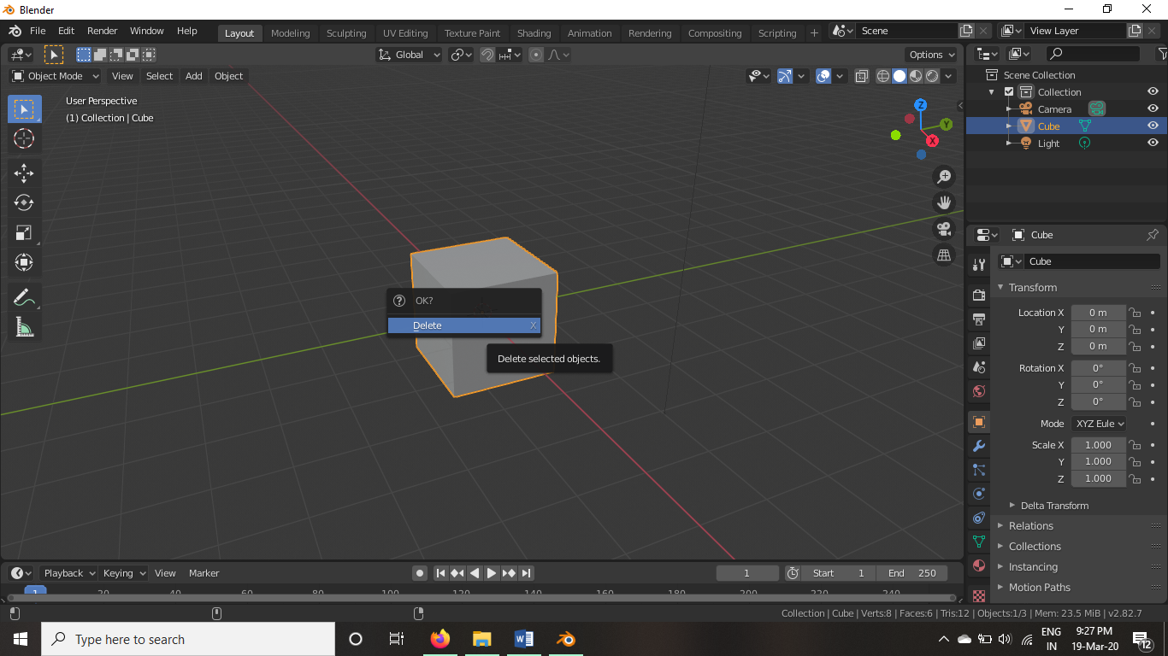

4: Then add a mesh of cylinder using commands shift+a then selecting mesh and then go to cylinder

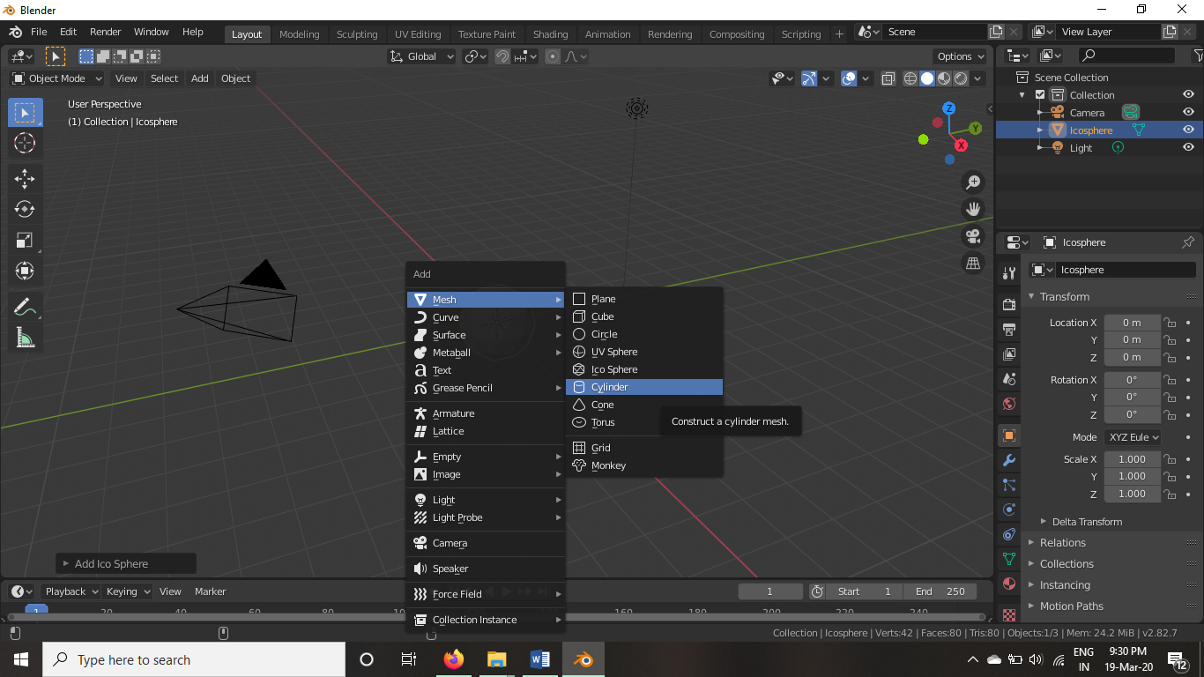

5: Transform the cylinder into cone using “s” key i.e size , “r” i.e rotate, “ctrl+r” i.e to add ties in the mesh.

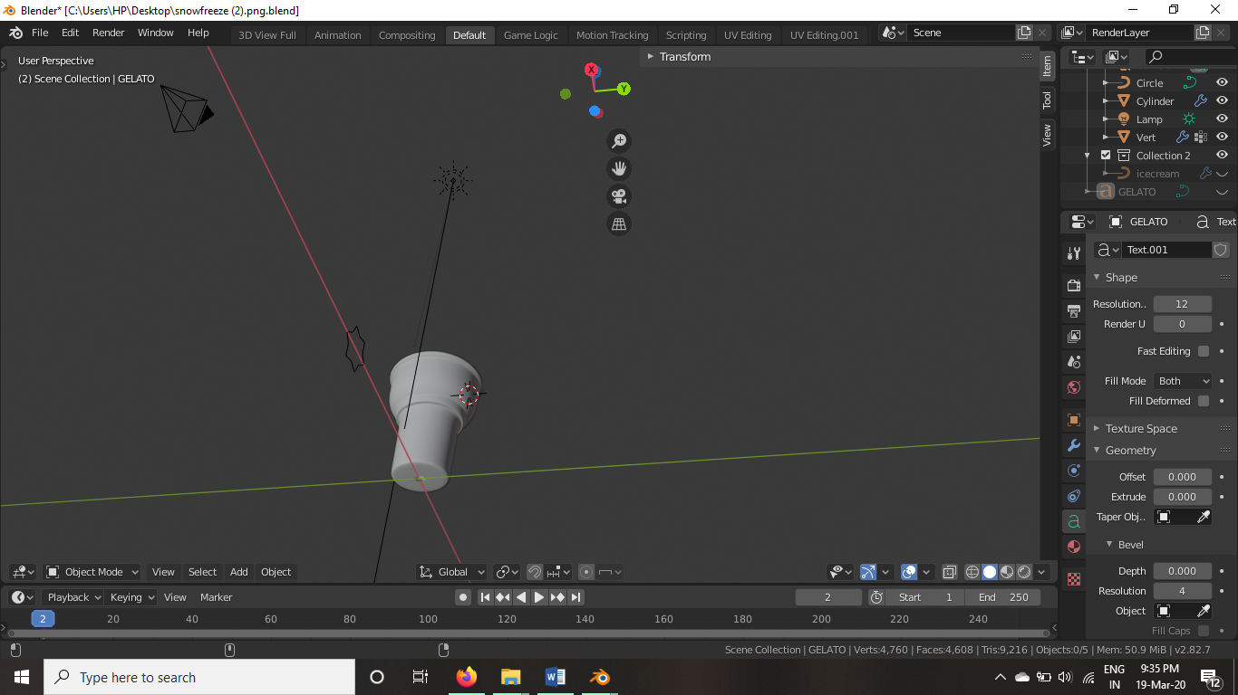

6: Now using modifiers, adding circle transforming it to a star like shape using “s” key and then extruding it using array modifier we make a long star like pipe structure and then using curve modifier we mould it into the curve to make a cream like structure.

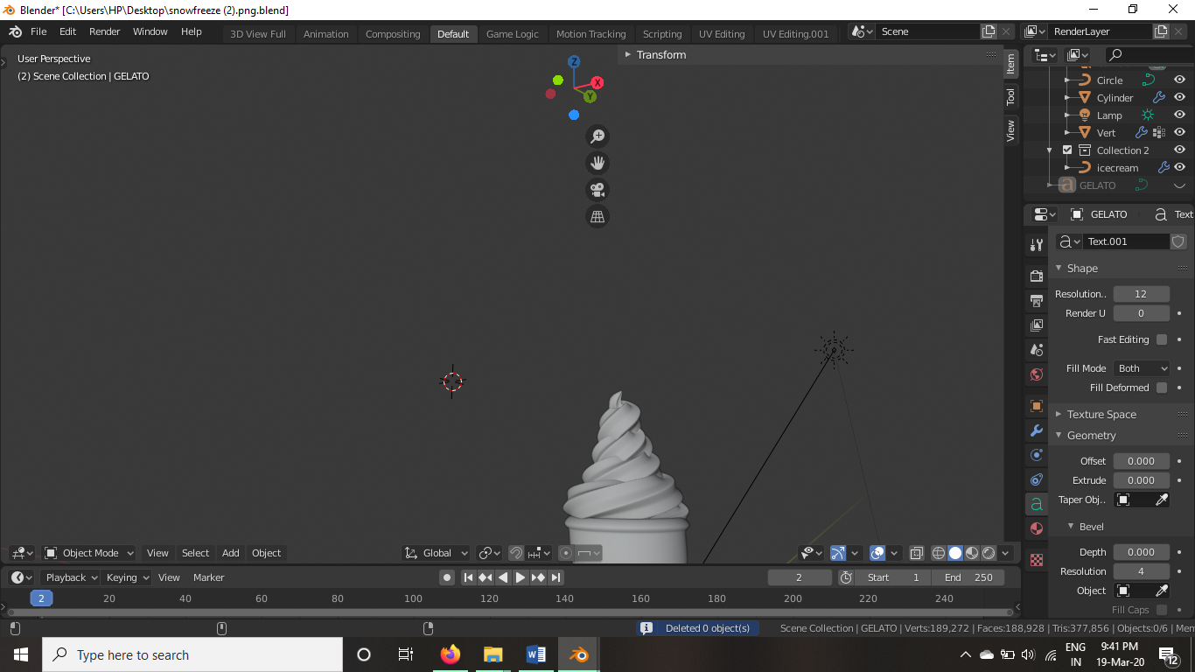

7: Now add colours to it accordingly and then render your image using f12 then save it as png format and the image is ready.

